**Electronic Repeat Dispensing – A brief guide for prescribers**

**Setting up eRD:**

1. Check that ‘total quantity’ and ‘issue duration’ *exactly* match on every repeat item, eg. all set to 56 tablets and 28 days duration, if BD dosing.
2. Highlight all repeat items for eRD. Select the ‘RD’ button to produce the eRD prescription. Set up PRNs SEPARATELY on individual eRD scripts, with a sensible frequency.
3. If the patient recently received a prescription then the first eRD script can be cancelled by pressing the red cross icon

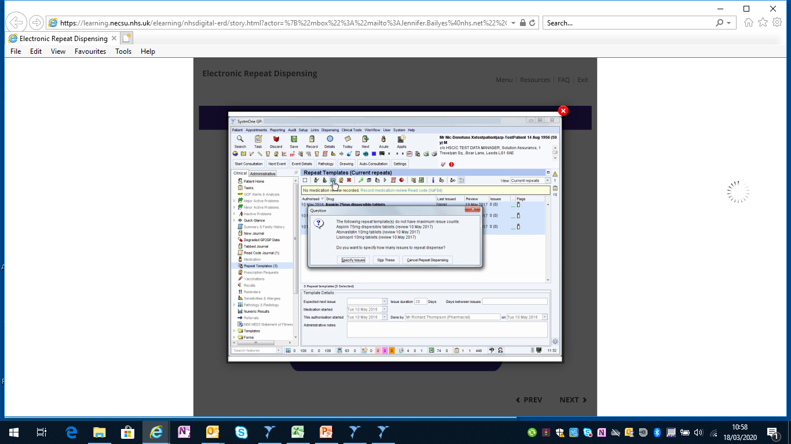

eRD allows prescribers to sign a batch of electronic prescriptions in advance. The CCG has made eRD a key priority, to maintain medication supply and reduce GP workload during the peak of the virus outbreak. Patients on eRD will liaise directly with the Community Pharmacy to obtain more medicine.

**Summary of eRD roll-out by the pharmacy team:**

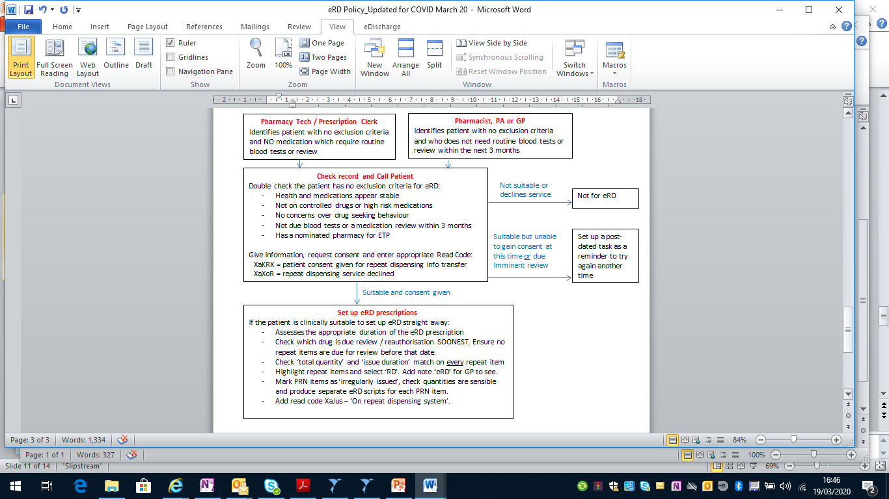

Endeavour to inform the nominated pharmacy that the patient is now on eRD.

**Support:**

For online eRD training: <https://learning.necsu.nhs.uk/nhs-digital-electronic-repeat-dispensing-elearning/>

For links to other eRD resources: <http://www.dorsetformulary.nhs.uk/> (see under ‘Covid-19 resources)

Pharmacy support: ***Insert names and contact details***

**Cancelling and re-syncing prescriptions:**

1. eRD scripts cannot be *amended* once they have been sent to the Spine. This is why we use eRD most for ‘stable’ patients.
2. If an item needs to be changed, it must be cancelled off the repeat with the red ‘STOP’ button. Then add it back on with the new directions, click the ‘RD’ button and set it so that it syncs with all of the other repeat items on the eRD script.
3. It may be preferable to stop ALL items on that script and add them all back on, to keep it as one eRD script.
4. An automatic task will be sent from the Spine to say if a cancellation has been ‘successful’ or ‘unsuccessful’. If unsuccessful, ensure that what you wanted to change is clear from the Tabbed Journal and forward the task to Admin or the Pharmacy Team to investigate.

