Prescribing in primary and community care during COVID 19 outbreak

Introduction
This document lays out a temporary approach that has been agreed by both Dorset CCG and DHC for the duration of the COVID-19 outbreak. Arrangements for prescribers that have been granted access to other systems, etc. that they didn’t have before, will be reviewed after six months, at which point access may be removed.
This document does not apply to hospital EPMA internal systems, including activity that deemed hospital activity such as ‘MIUs’ and outpatients.
Electronic Prescription Service (EPS) (4) refers to the digital transmission of an “FP10” prescription from a prescriber to a community pharmacy.
It should be noted that this document specifically separates Medical (Doctors) and Non-Medical Prescribers (NMPs). Due to some contractual and legislative differences, different processes are needed to ensure governance is sufficient to protect patients and individual practitioners.

Stockpiling
Patients and organisations will be tempted to stockpile medicines during this emergency period. It is very important to avoid this for the sake of the national supply chain. Prescription duration should routinely be 28 days. If patients have previously had 2/3 months prescriptions, then that may be maintained, but UNDER NO CIRCUMSTANCES should durations be increased, or multiple one month prescriptions be issued. This will have an adverse impact on the supply chain as well as community pharmacy capacity. It will be apparent in ePACT data if practices have been doing this irresponsibly.
Primary Care Networks must not keep stocks of palliative care drugs. These will be available through existing arrangements with community pharmacies.

Digital
Wherever possible prescriptions should be digitally transferred from prescriber to a pharmacist. This avoids the risk of handing over potentially infected pieces of green paper, but also enables remote working and 2m distancing both with prescriber and pharmacist. However, paper prescriptions remain valid and the PSNC have issued a reminder of this. https://psnc.org.uk/our-news/covid-19dispensing-paper-prescriptions/ . Note, the primary legislation needs to be in place to support EPS. Not all settings will be able set up EPS, even though the IT technology may be in place. Please refer to Natasha King or Katherine Gough for advice.
In General practice (delivery of General Medical Services (GMS)/Personal Medical Services (PMS)) is enabled with EPS4 for acute prescriptions, and all practices MUST be identifying and converting clinically suitable people onto electronic Repeat Dispensing (eRD), with 13months x28 days as the norm. Therefore, in whatever the site (hot/cold/patient home/care home etc.) when GPs or other prescribers providing PMS/GMS services need to prescribe, they must use the practice system to generate EPS prescriptions.

Prescribing from other GP practice sites
GPs have a prescribing code associated with their GP practice. Where they may work in another practice in their PCN, either due to identification of hot sites or cover due to sickness etc. They may need to be logged as a locum in the other practice system, unless shared admin is in place. See below re shared admin. NMPs cannot be set up as ‘locums’ and will need to be added as a prescriber on the individual GP surgery system. Guidance can be sought from the CCG on this process.

Other hospital sites and DHC premises
Prior to this outbreak EPS was not functional from other organisations sites other than GP practices (GP SystmOne module). We understand that this may be changing (technical and legislative changes), and that it may be enabled from other modules, e.g., NHS111/Dorset Integrated Urgent Care Service. Please await guidance from system suppliers on the implications and possibilities for this. Any roll-out of EPS in DHC will be project managed with the involvement of both Clinical Systems and the Digital Medicines Team.

Hot sites
Where ‘Shared Admin’ is in place, then prescribing through this functionality is preferred method of prescribing for GPs. NMPs cannot prescribe in this way to access EPS functionality and must be directly linked to individual practices. The GP can access the hot site rota from their own login and access the patients seamlessly. There is a process involved in switching on Shared Admin which has been considerably ‘slimmed down’ to facilitate quick action in this crisis period. If you wish to know more about Shared Admin please contact Steve Howes Steve.howes@dorsetccg.nhs.uk or digital.support@dorsetccg.nhs.uk
Where shared Admin is not available, and If you are planning to use remote booking for your hot site rota, then each GP will need to be given access to the site hosting the remote booking rota. When they are logged in they will need to have the prescribing set up like you would a locum. They would be using the PAA ID of one of the regular GPs or partners at the hosting site. The prescribing charges will all be against the hosting site. NMPs cannot be set-up as a locum and therefore need to be registered as a prescriber for each individual surgery.

Non-Medical Prescribers primary care employed
To add non-medical prescribers who are prescribing for primary medical service to your J code contact medicine management team Dorset CCG. This form needs to be completed and returned to the CCG at the e-mail address on the form. Careful consideration of which NMPs need to be added to each practice is requested, it would be a large administrative burden to add an NMP to all surgeries in a PCN. This could cause a delay for other NMPs being added to other surgeries where the need is urgent.

NMP Change of Circ
Sept18.doc

Instructions for prescriber settings
TPP EPS Organisation
User Prefs V3 (002).p

Community prescribers, frailty teams, Integrated Care
Prescribing is presently done on prescriptions for employing organisation (DHC). At present this means that some people will still need to use paper. There are exceptions on a case by case basis, where prescribing is being done on behalf of practices and as such prescribers can be set up on individual practice systems (e.g. Diabetes Specialist Nurses). These cases are treated on a case by case basis between CCG & DHC medicines teams.
Where the prescriber is a DHC employee, then the request must in the first instance be via the DHC Pharmacy/Medicines Management Team. NMPs for hot sites will be set up in this way. Access to prescribe via GP Systems, set up to manage services during the outbreak, will be reviewed after 6 months, and may revert back to pre-COVID-19 arrangements.
There may be a national switch on of EPS in these settings in the near future, please watch this space and keep in touch with medicines teams.

Formulary
DHC and the CCG are working together to enable the primary care formulary currently published to GP Practices to be also published to DHC SystmOne Modules.
Mental Health
Currently there is no information coming down with regard to EPS in RiO.

SystmOne Code formats for prescribers set ups (including Paramedic prescribers)
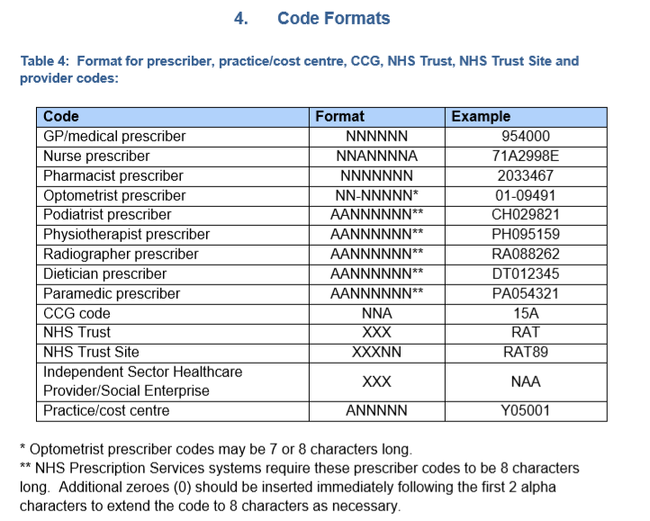
Medicines Teams DHC and Dorset CCG
Katherine Gough/Natasha King
April 2020

